Comp 3710

Assignment 5

Zikun Xu

Guide for user:

I build my app on Android 10.0. So, user need Android 10.0 or newer device to run this App.

Step 1

Open my app

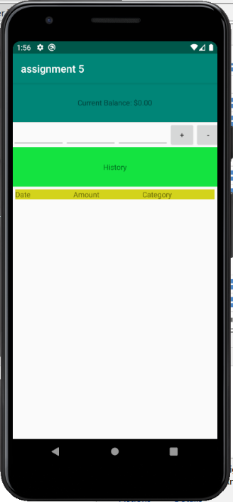

Step 2

Add the money you earn. There are three empty blank, from left to right is date, amount of money and where you money from or where you spend.

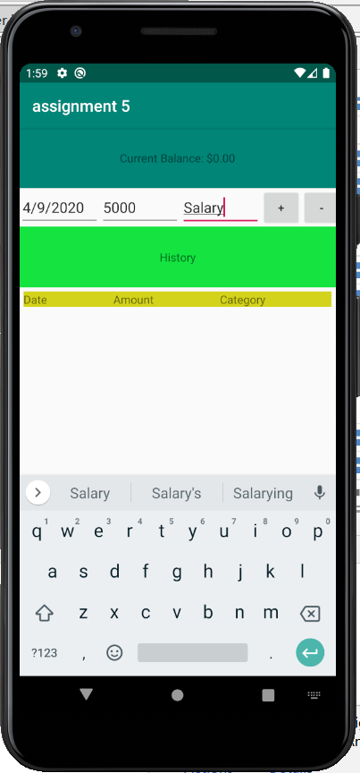

Step 3

Click the + or -, and you can see the information in the history.

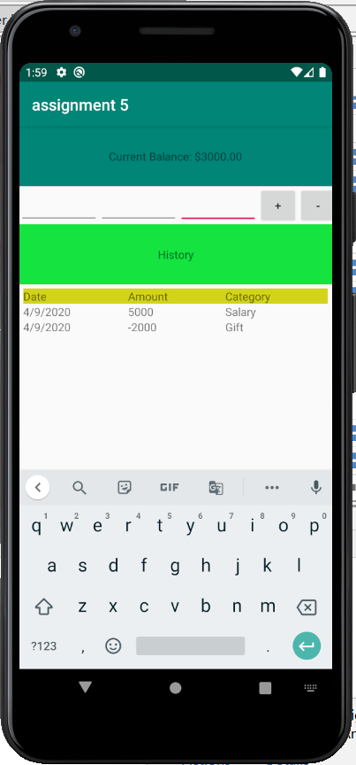

Step 4

Try more time

